ASSIGNMENT -1

1.Go to the chrome and open remix platform

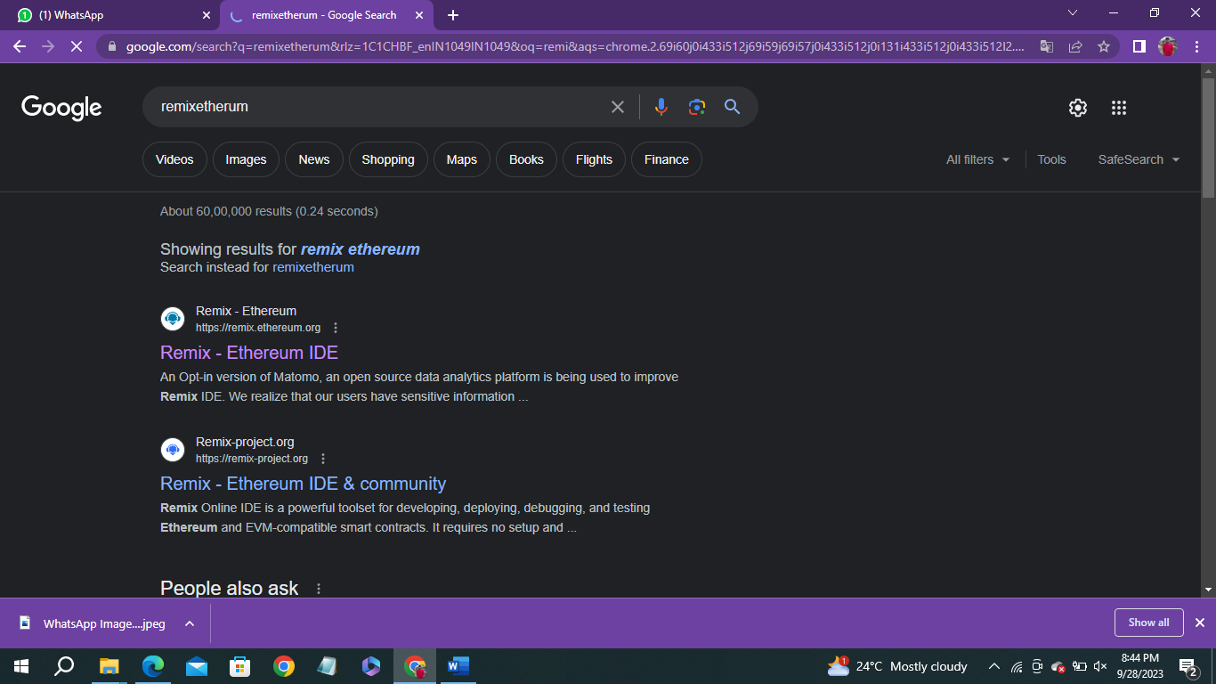

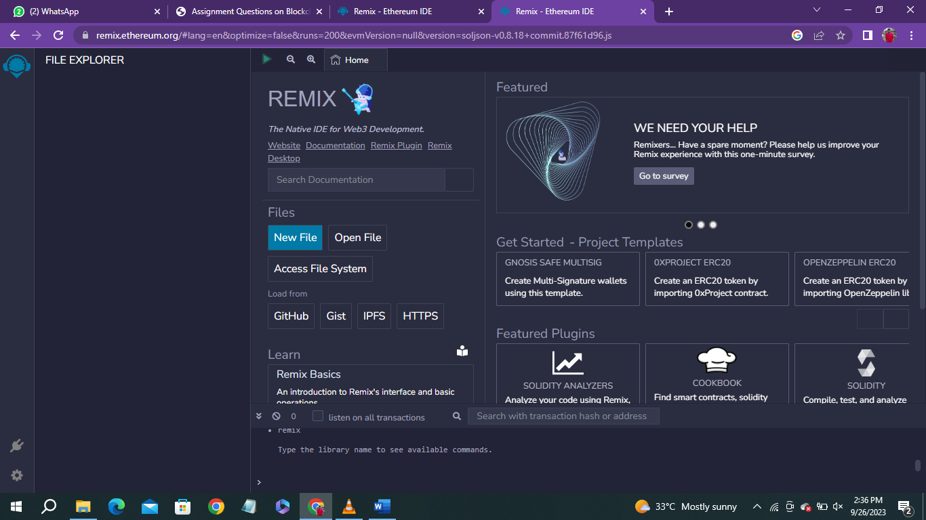

2.Open the remix page and create a new file



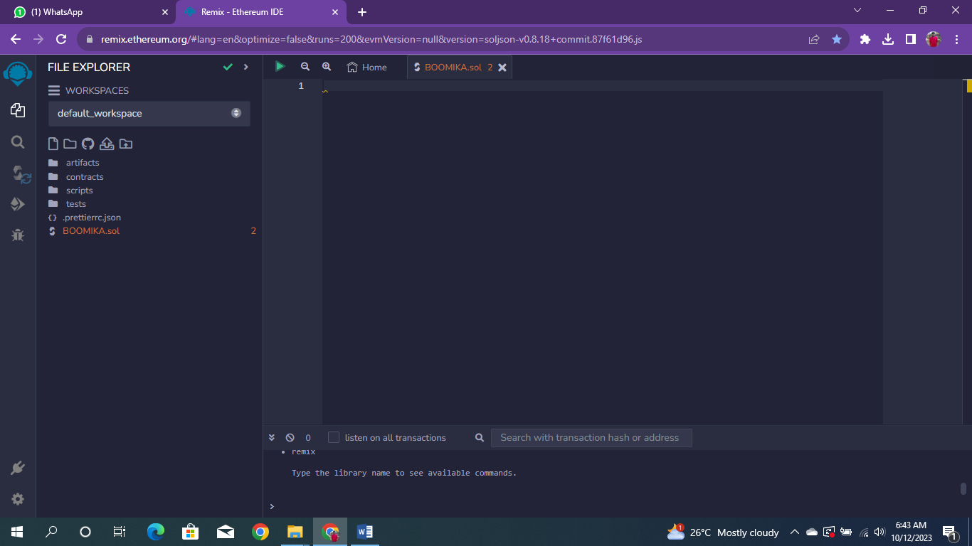

3.In that newly created file, create a program to return your string, "Zone name"

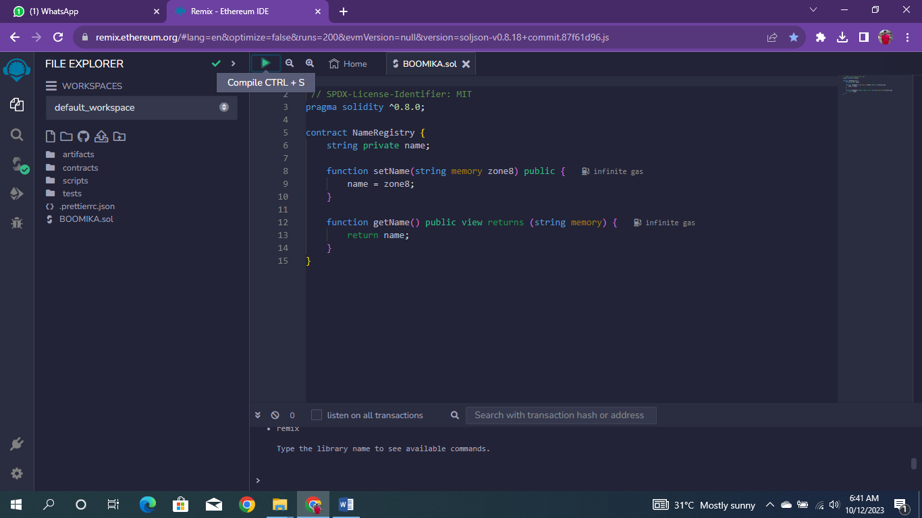

4.Save the program and compile it to get the ABI and Bytecode

BYTECODE: 

ABI:

[

{

"Inputs": [],

"name": "getName",

"outputs": [

{

"internalType": "string",

"name": "",

"type": "string"

}

],

"stateMutability": "view",

"type": "function"

},

{

"inputs": [

{

"internalType": "string",

"name": "zone8",

"type": "string"

}

],

"name": "setName",

"outputs": [],

"stateMutability": "nonpayable",

"type": "function"

}

]]

5.Finally Deploy it to display the output

